**CSCE 590 Introduction to Image Processing**

TO: Professor Ioannis Rekleitis  
FROM: Adam Einstein

DATE: February 10, 2021  
SUBJECT: Assignment 1

1. **Various Images**

**Image 1:** **590-HW1-P1.png 🡪 590-HW1-P1.jpg**

**File Size:** 3.75 MB **File Size:** 248 KB

**Dimensions:** 2048, 1529, 3 **Dimensions:** 2048, 1529, 3

**Pixel Depth:** 24-bit **Pixel Depth:** 24-bit

**Mean:** 68.2857 **Mean:** 68

**Min:** 45 **Min:** 45

**Max:** 112  **Max:** 112

From this format change we can see a large change in file size as well as slight change in mean intensity value.

**Image 2:** **590-HW1-P2.jpg 🡪 590-HW1-P2.tiff**

**File Size:** 4.43 MB **File Size:** 69.07 MB

**Dimensions:** 4000, 6000, 3 **Dimensions:** 4000, 6000, 3

**Pixel Depth:** 24-bit **Pixel Depth:** 24-bit

**Mean:** 68.0714 **Mean:** 70.4667

**Min:** 45 **Min:** 45

**Max:** 112 **Max:** 116

From this format change we can see a change in file size as well as slight change in mean intensity value and max intensity value.

**Image 3:**  **590-HW1-P3.tiff** 🡪 **590-HW1-P3.png**

**File Size:** 27.48 MB **File Size:** 4 KB

**Dimensions:** 2764, 2606, 4 **Dimensions:** 656, 874, 3

**Pixel Depth:** 36-bit **Pixel Depth:** 24-bit

**Mean:** 70.5333 **Mean:** 68.4286

**Min:** 45 **Min:** 45

**Max:** 116  **Max:** 112

From this format change we can see a large change in file size as well as slight change in mean intensity value and max intensity value. We also can see a change in pixel depth when saving from tiff to png format.

All images were free stock photos downloaded from <https://www.pexels.com/>

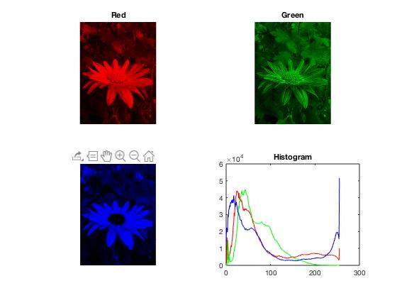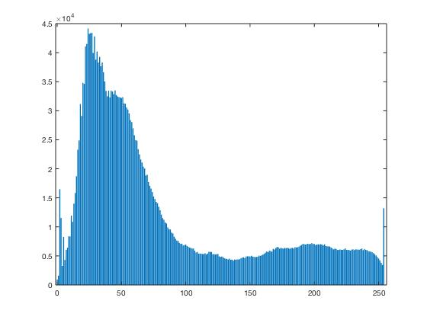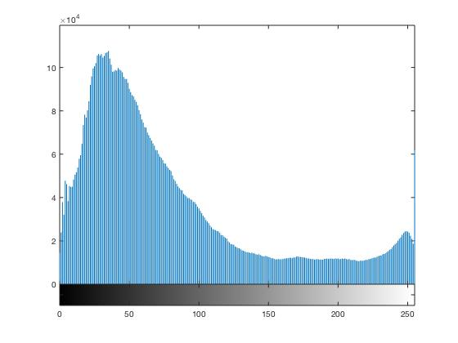

1. **Histogram**

**Image 1: 590-HW1-P1.png**

The figures above represent the intensity histograms for my image 1. The RGB histogram above displays the color intensities for each color, while the histogram on the right represents the images overall intensity. This image in particular has a strong presence of red and blue colors.

**Image 2: 590-HW1-P2.jpg**

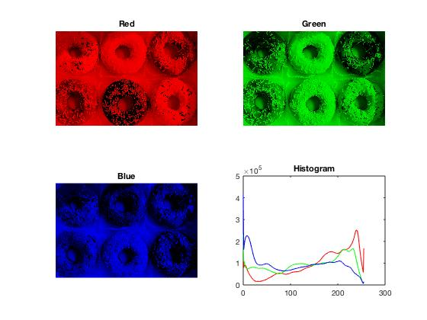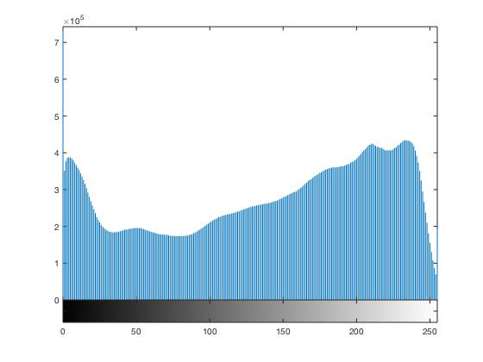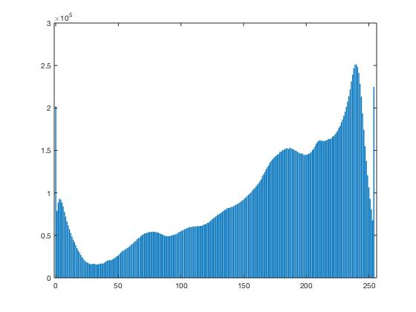

The figures above represent the intensity histograms for my image 2. The RGB histogram above displays the color intensities for each color, while the histogram on the right represents the images overall intensity. This image in particular has a strong presence of red and green colors.

**Image 3: 590-HW1-P3.tiff**

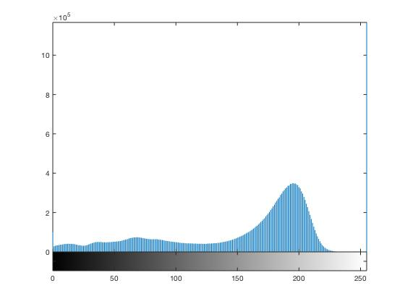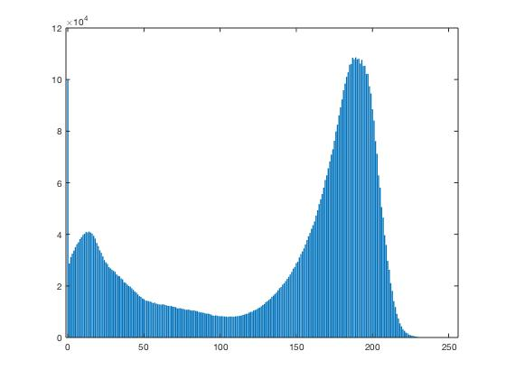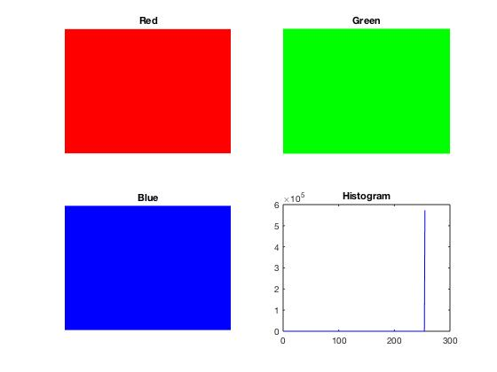

1. **Single Image Operations**

**Image 1:** **590-HW1-P1.png**

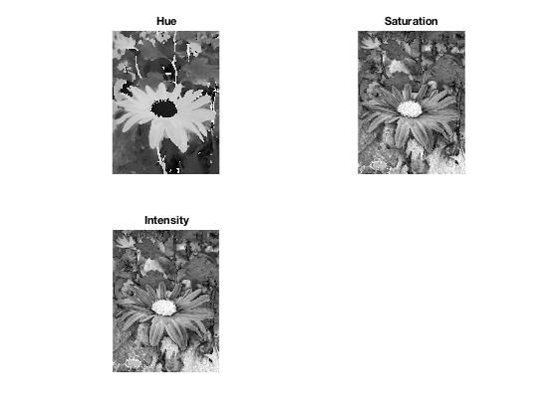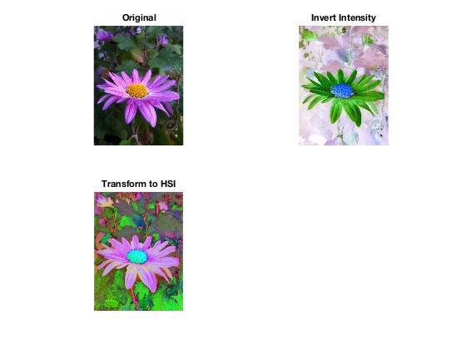

**Image 2:** **590-HW1-P2.jpg**

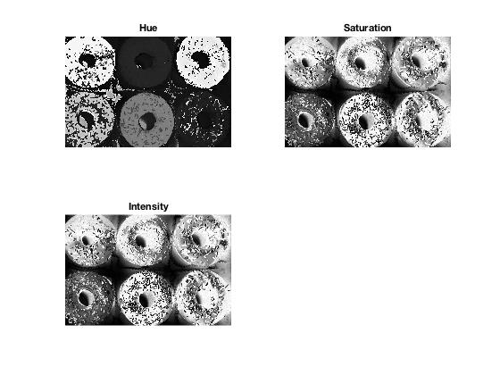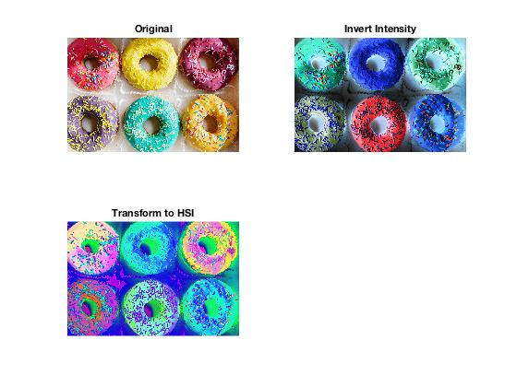

**Image 3:**  **590-HW1-P3.tiff**

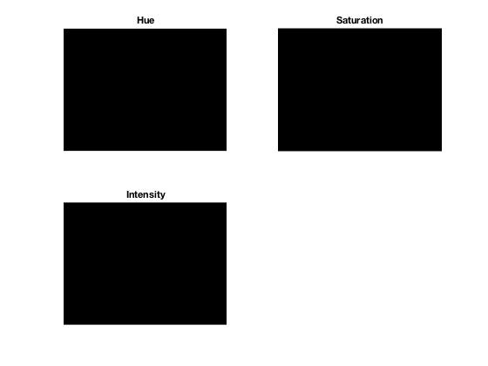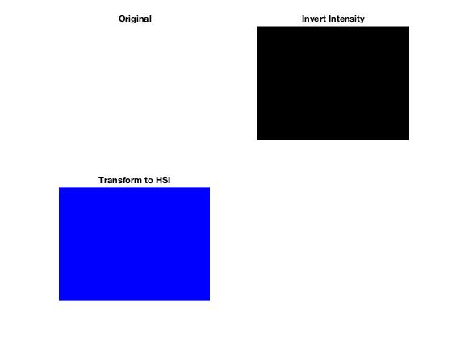

Here we took the original image, inverted its intensity, and then converted it the HSV model. Additionally, included is the individual Hue, Saturation, and Intensity images.

**My Code**

**1.**

a = imread("590-HW1-P1.png")

imwrite(a,'image01.jpg')

imshow("image01.jpg")

size(a)

info = imfinfo('')

info.BitDepth

maxValue = max(max('590-HW1-P1.jpg'))

**2.**

img = imread("590-HW1-P1.jpg");

Size = size(img);

Bd = 8;

Histo = zeros(1,(2^(Bd)));

for i=1:Size(1)

for j=1:Size(2)

Temp = img(i,j);

Histo(Temp+1) = Histo(Temp+1) + 1;

end

end

bar(0:(2^(Bd) -1),Histo)

imhist(img)

//

A = imread('590-HW1-P1.jpg');

R=A;

G=A;

B=A;

R(:,:,2)= 0;

R(:,:,3)= 0;

subplot(2,2,1)

imshow(R)

title('Red');

G(:,:,1)= 0;

G(:,:,3)= 0;

subplot(2,2,2)

imshow(G)

title('Green');

B(:,:,1)= 0;

B(:,:,2)= 0;

subplot(2,2,3)

imshow(B)

title('Blue');

Red = A(:,:,1);

Green = A(:,:,2);

Blue = A(:,:,3);

[yRed, x] = imhist(Red);

[yGreen, x] = imhist(Green);

[yBlue, x] = imhist(Blue);

subplot(2, 2, 4);

plot(x, yRed, 'Red', x, yGreen, 'Green', x, yBlue, 'Blue');

title('Histogram');

**3.**

rgbImage = imread('590-HW1-P3.png')

hsv = rgb2hsv(rgbImage);

h = hsv(:, :, 1);

subplot(2,2,1)

imshow(h);

title('Hue');

s = hsv(:, :, 2);

subplot(2,2,2)

imshow(s);

title('Saturation');

v = hsv(:, :, 3);

subplot(2,2,3)

imshow(s);

title('Intensity');

img=imread('590-HW1-P3.png');

subplot(2,2,1)

imshow(img);

title('Original');

y=255-img;

subplot(2,2,2);

imshow( y )

title('Invert Intensity');

hsi = rgb2hsv(img);

subplot(2,2,3);

imshow(hsi);

title('Transform to HSI');